PROJECT REPORT

On

# Pinogram App

Submitted in partial fulfilment of the requirement for the Course BEE (22CS026) of

COMPUTER SCIENCE AND ENGINEERING

B.E. Batch-2022

in

Jan -2025



|  |  |
| --- | --- |
| Under the Guidance of Sudeep Sir | Submitted By |
| Name of the Project Guide Sudeep Sir | Jai Kumar Goel |
| Designation of the Project Guide | Roll. No. 2210991693 |
|  | Japit Arora |
|  | Roll. No. 2210991695 |
|  |
|  |
|  |

DEPARTMENT OF COMPUTER SCIENCE AND ENGINEERING

# CHITKARA UNIVERSITY

PUNJAB



**CERTIFICATE**

This is to be certified that the project entitled “Title of the Major Project” has been submitted for the Bachelor of Computer Science Engineering at Chitkara University, Punjab during the academic semester January 2024- May-2024 is a bonafide piece of project work carried out by “Name’s and roll no’s of the students group” towards the partial fulfillment for the award of the course Integrated Project (CS 203) under the guidance of “Project Guide Name” and supervision.

**Sign. of Project Guide :**

Name of Project Guide

(Designation & Department)

 **CANDIDATE’S DECLARATION**

We, NAME AND Roll No’s OF THE STUDENTS GROUP, B.E.-2021 of the Chitkara University, Punjab hereby declare that the Integrated Project Report entitled “TITLE OF PROJECT” is an original work and data provided in the study is authentic to the best of our knowledge. This report has not been submitted to any other Institute for the award of any other course.

**Sign. of Student 1** **Sign. of Student 2**

Jai Kumar Goel Japit Arora

2210991693 2210991695

**Place: Chitkara University**

**Date: 10-09-2024**



**ACKNOWLEDGEMENT**

It is our pleasure to be indebted to various people, who directly or indirectly contributed in the development of this work and who influenced my thinking, behavior and acts during the course of study.

We express our sincere gratitude to all for providing me an opportunity to undergo Integrated Project as the part of the curriculum.

We are thankful to “Project Guide Name” for his support, cooperation, and motivation provided to us during the training for constant inspiration, presence and blessings.

We also extend our sincere appreciation to “Project Guide name and External Guidename (if any) who provided his valuable suggestions and precious time in accomplishing our Integrated project report.

Lastly, We would like to thank the almighty and our parents for their moral support and friends with whom we shared our day-to day experience and received lots of suggestions that improve our quality of work.

**Jai Goel Japit Arora**

**2210991693 2210991695**

INDEX

|  |  |  |
| --- | --- | --- |
| Sr.no. | Topics | Page no. |
| 1. | ABSTRACT | 3 |
| 2. | INTRODUCTION | 4-6 |
| 3. | PROBLEM STATEMENT | 7-8 |
| 4. | PROJECT DESIGN | 9-25 |
| 5. | SNAPSHOT OF RESULT | 26-27 |
| 6. | MONGO DB | 28-29 |
| 7. | CONCLUSION | 30-31 |
| 8. | REFERENCE | 32 |

1. **Abstract:**

Pinogram is a social media platform that has transformed the way people connect, communicate, and share visual content globally. Launched in 2024, Pinogram initially focused on photo sharing, allowing users to apply filters and share their images. Over time, it will evolve into a multifaceted platform, incorporating features like Stories, IGTV, Reels, and shopping functionalities.

Pinogram success lies in its ability to blend personal expression with community building, enabling users to curate aesthetically pleasing profiles while fostering engagement through likes, comments. The platform's algorithm, which prioritizes personalized content based on user behavior, has made it a powerful tool for influencers, brands, and businesses to reach targeted audiences.

Moreover, Pinogram has played a significant role in shaping digital culture, popularizing trends, and driving social movements. Its visual nature has made it particularly influential in areas like fashion, travel, and lifestyle, where imagery is paramount. Despite facing criticism for issues like algorithmic biases, mental health concerns, and the promotion of unrealistic standards, Pinogram remains one of the most popular and influential social media platforms globally, continuously adapting to the changing digital landscape.

1. **Introduction**

Imagine a social media platform that strips away the complexities and focuses purely on the essence of online interaction: liking, commenting, and sharing thoughts through posts. This platform is designed to be simple yet effective, allowing users to engage with each other's content in a straightforward manner. Users can create posts, and others can respond by either liking or commenting, creating a direct and meaningful connection.

Unlike platforms that offer a multitude of features, this one is built around minimalism, encouraging users to focus on the quality of their interactions rather than the quantity. The only options available—liking, commenting, and deleting posts—make the platform easy to navigate and use, fostering a more authentic and distraction-free social experience.

By seeing and engaging with others' posts, users can form communities, share ideas, and support each other's content without the noise of excessive features. This simplicity allows for genuine connections and discussions, making the platform a refreshing space in a world often cluttered with digital distractions.

* The app you're describing would be a minimalist social media platform where users can perform only three basic functions: like posts, comment on them, and delete their own posts. This platform would prioritize simplicity and straightforward interaction, with no extra features such as stories, direct messaging, or complex algorithms.
* Here's a summary of what such an app would be:
* Key Functions:
  + Like: Users can express appreciation or approval of posts by liking them.
  + Comment: Users can engage in conversation or share their thoughts by commenting on other people’s posts.
  + Delete Post: Users can delete their own posts whenever they choose.
* User Experience:
  + Users can view others' posts, scroll through a feed, and engage with content via likes and comments.
  + There would be no complex algorithms curating content—just a simple feed of posts from people they follow or a general timeline.
* Focus:
  + The app would foster a clean, distraction-free environment for users who prefer straightforward interaction.
  + The lack of extra features like direct messaging or advertising could help create a more genuine and relaxed social experience.
* This kind of app would appeal to users seeking a more focused, no-frills social media experience, where the core emphasis is on engaging with posts in a simple and meaningful way.

Objectives :

The objective of this minimalist social media platform is to create a focused, user-friendly environment that encourages meaningful interaction and authentic engagement. By limiting features to only liking, commenting, and deleting posts, the platform aims to:

1. Simplify Social Interaction: Streamline the user experience by removing unnecessary features and distractions, allowing users to focus solely on content and engagement.
2. Promote Genuine Connections: Foster a community where interactions are based on direct responses to content, encouraging thoughtful comments and authentic appreciation through likes.
3. Reduce Digital Overload: Provide a less cluttered social media experience, reducing the pressure of constant notifications, messages, and the complexities of other platforms.
4. Encourage Mindful Posting: By offering a simple delete option, users can curate their content more intentionally, knowing they can easily remove posts that no longer resonate with them.
5. Enhance Privacy and Control: Give users more control over their content with a straightforward ability to delete posts without the worry of additional complexities or archival features.

The overall goal is to create a social media platform that prioritizes quality of interaction over quantity, offering a space where users can engage in a more relaxed, focused, and meaningful manner.

**3.Problem Statement:**

To design the same web design as an app with EJS , CSS and other framework libraries.

**3.1 Requirements:**

**\*EJS:-** EJS (Embedded JavaScript Templates) is a simple and powerful templating engine for Node.js, used for generating HTML markup with plain JavaScript. It allows developers to embed JavaScript code directly within their HTML files, making it easy to dynamically generate content and render web pages based on data.

**Key Features:**

1. **JavaScript Embedded Syntax**:
   * EJS allows you to embed JavaScript logic within HTML using special delimiters, such as <%= %> for outputting values and <% %> for executing JavaScript code without output.
2. **Fast and Efficient**:
   * EJS is designed to be fast and lightweight, making it suitable for high-performance applications. It compiles templates into JavaScript functions, ensuring quick rendering of HTML pages.
3. **Flexibility**:
   * It offers a flexible way to generate HTML, allowing the use of JavaScript expressions, loops, conditionals, and more within the template. This flexibility makes EJS suitable for a wide range of use cases, from simple static pages to complex, data-driven applications.
4. **Partial Views**:
   * EJS supports partials, allowing you to include reusable pieces of code (like headers, footers, or navigation bars) across different templates, promoting code reusability and maintainability.
5. **Layout Inheritance**:
   * EJS provides layout support, enabling developers to define a base template (like a master page) and extend it with other templates. This feature is helpful in maintaining a consistent structure across multiple pages of an application.
6. **Easy Integration with Express.js**:
   * EJS is commonly used with Express.js, a popular web application framework for Node.js. It can be easily integrated into an Express application to render dynamic web pages, making it a go-to choice for server-side rendering in Node.js projects.

**\*CSS:-** Cascading Style Sheets(CSS)is an essential tool for designing and styling web pages, ensuring that a website looks visually appealing and functions seamlessly across various devices.For a photoshoot website,CSS plays a critical role in creating a professional and engaging user experience. By controlling the layout,typography,colors,and responsive design,CSS allows the website to showcase high-quality images and content effectively.The use of CSS ensures that elements such as headers,navigation menus,and galleries are not only aesthetically pleasing but also intuitive and easy to navigate.

**4. Project Design:**

This project aims to develop a social media platform by using EJS,CSS.

**4.1 Folder Structure:-**

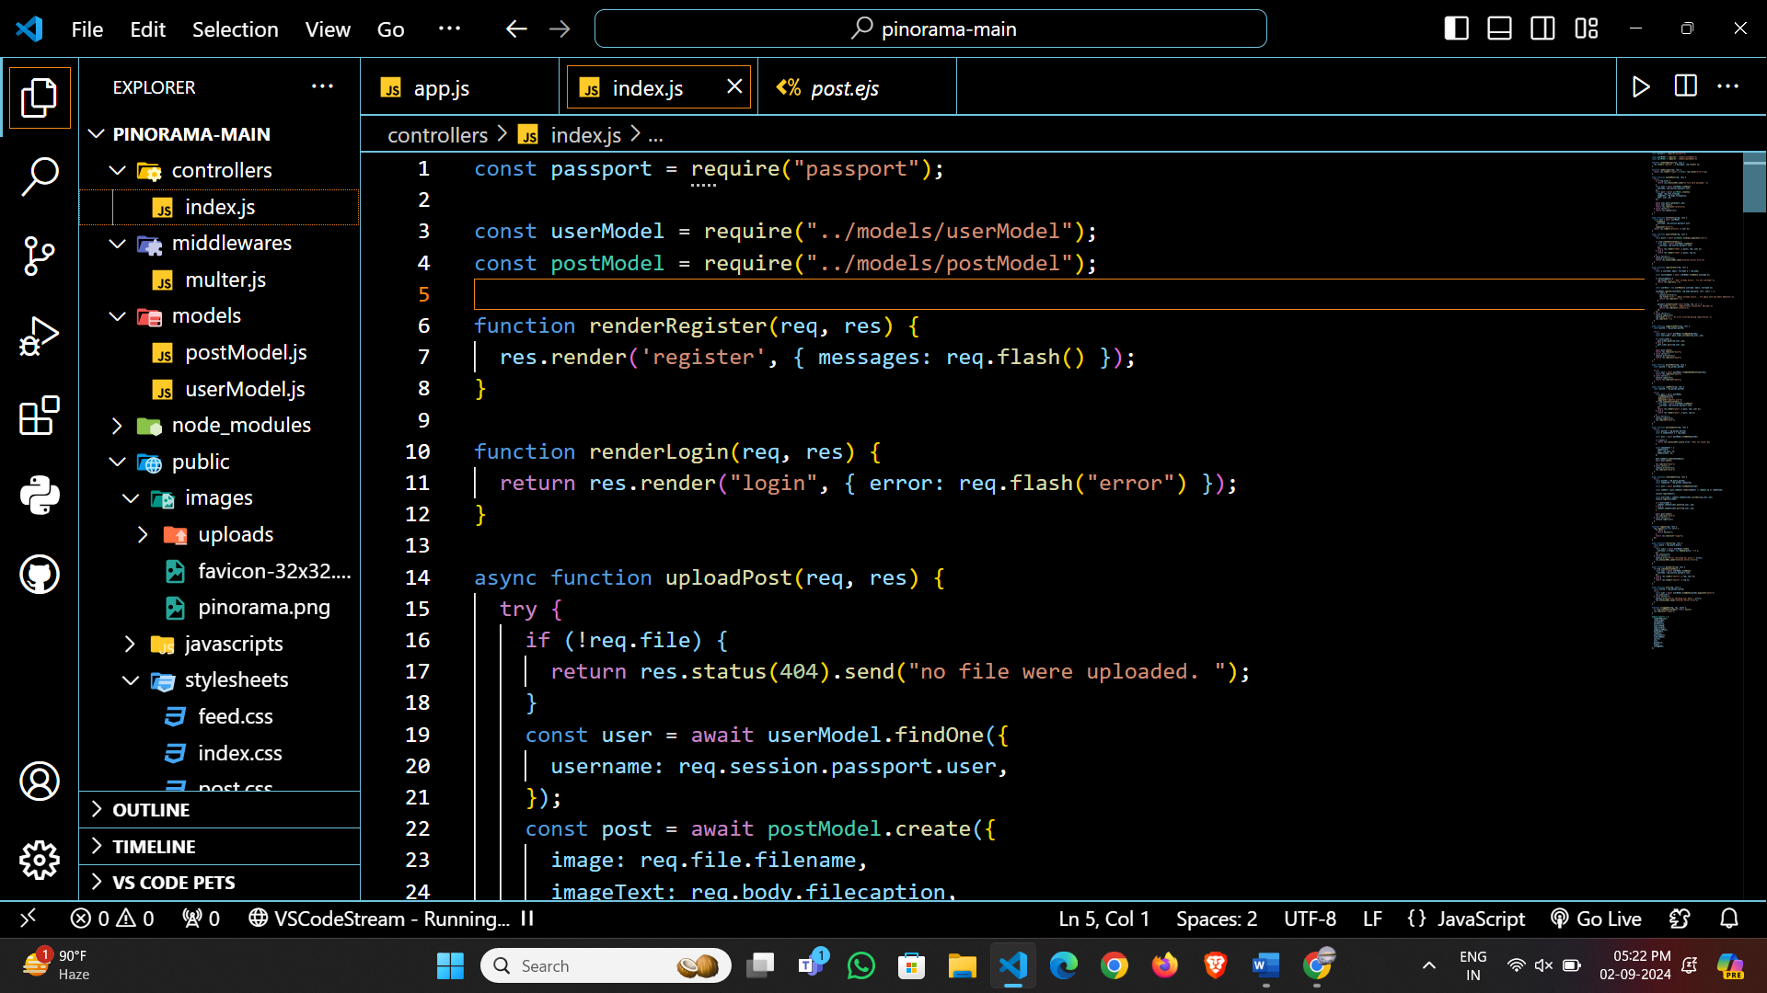

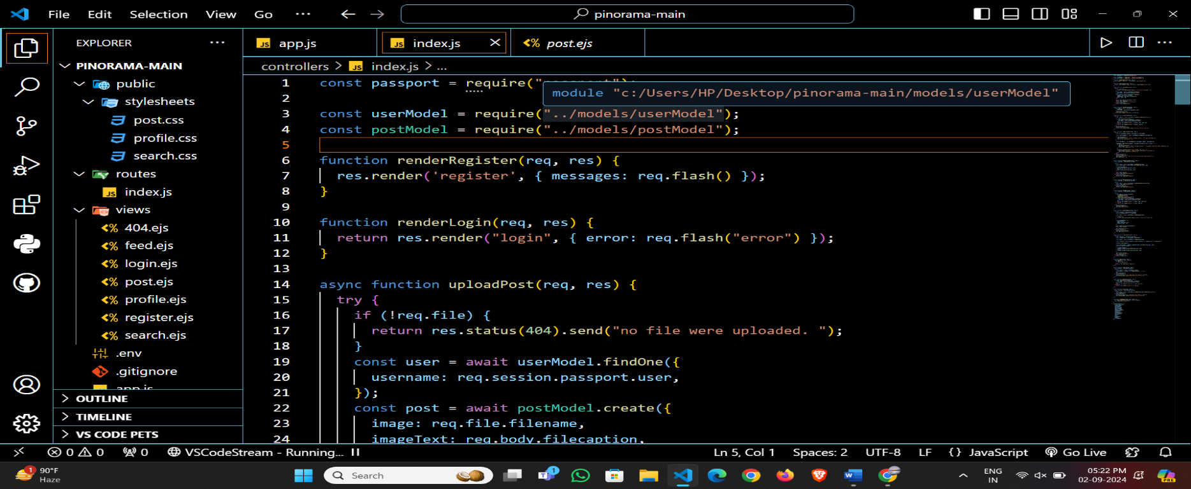

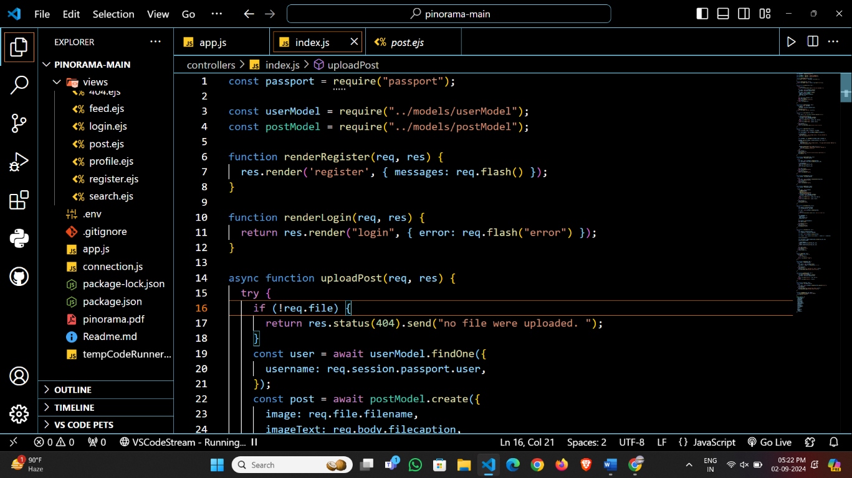

**4.2 Methodology:-**

The following shows the use of code of the project:

**\* MODELS FOLDER:**

* PostModel.js:

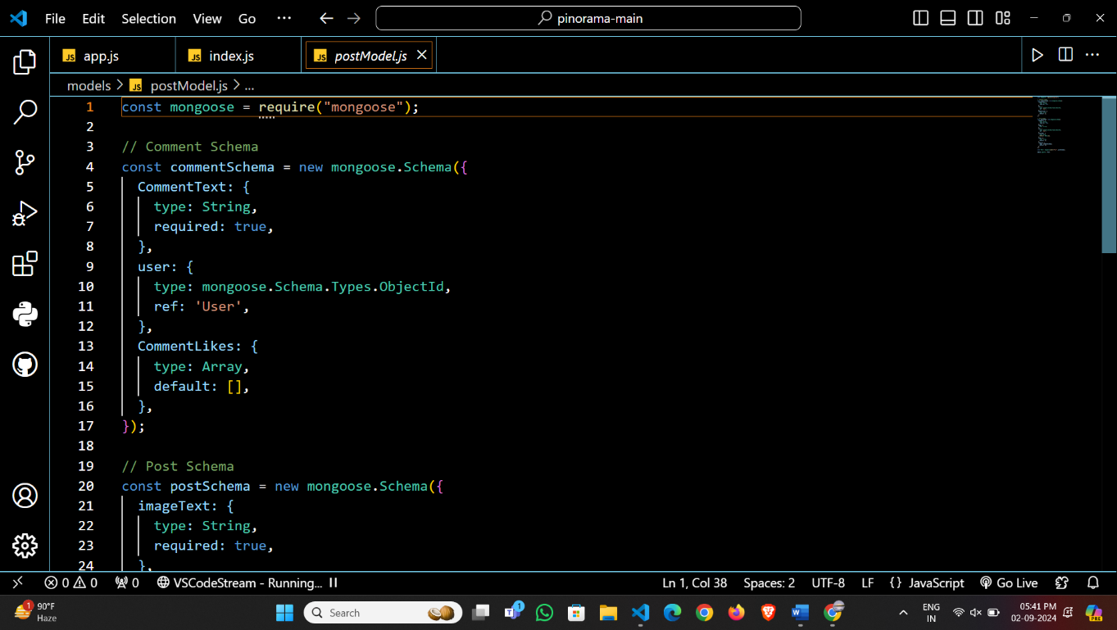

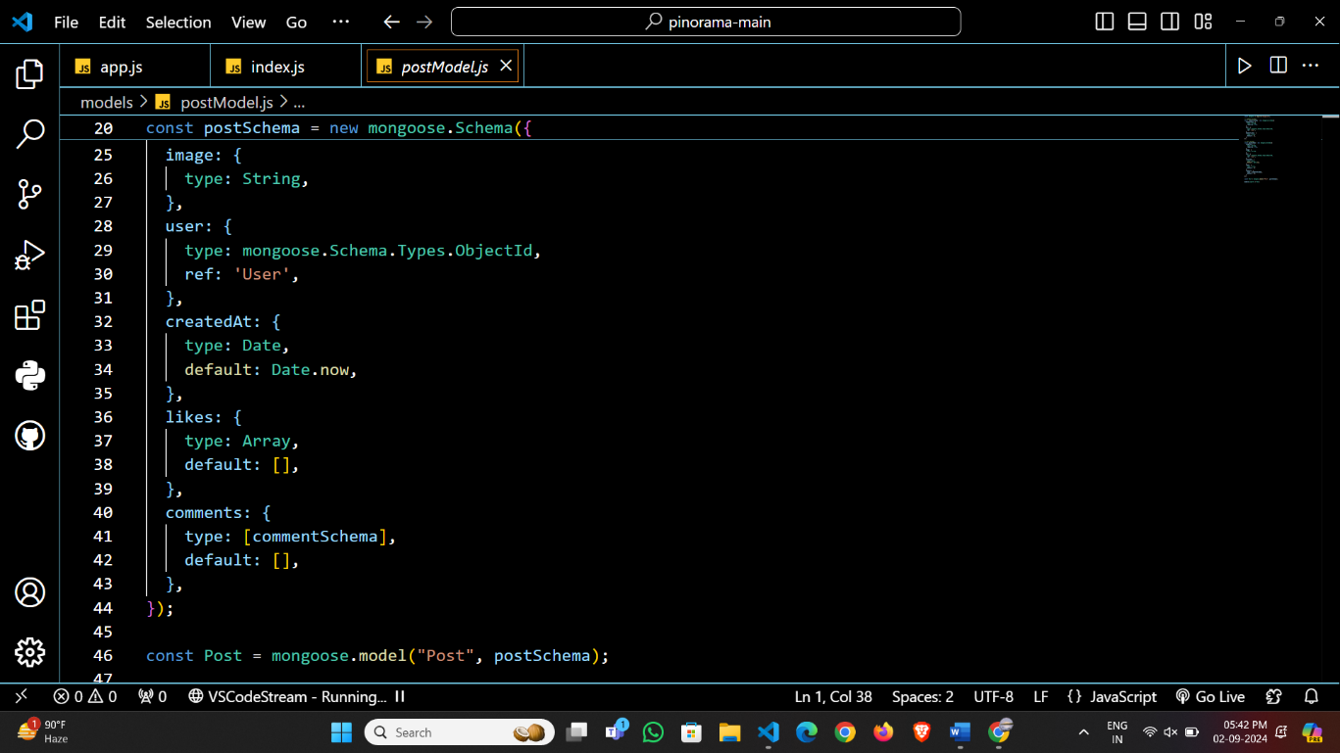

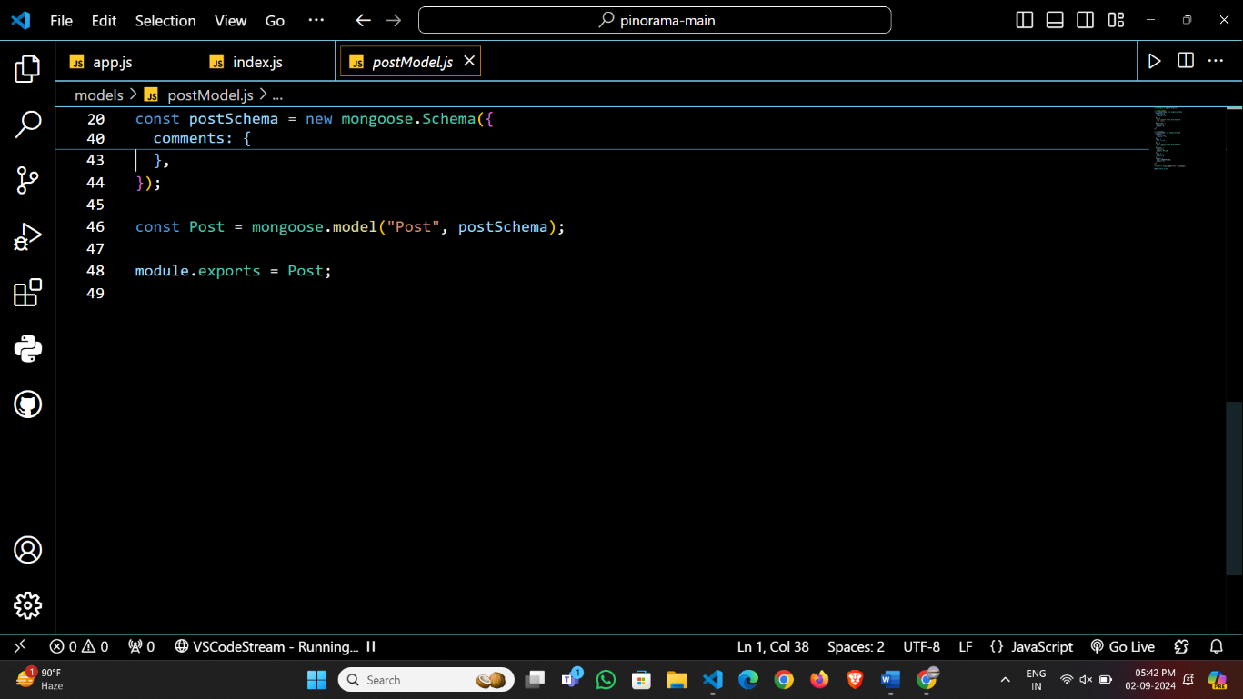

* UserModel.js:

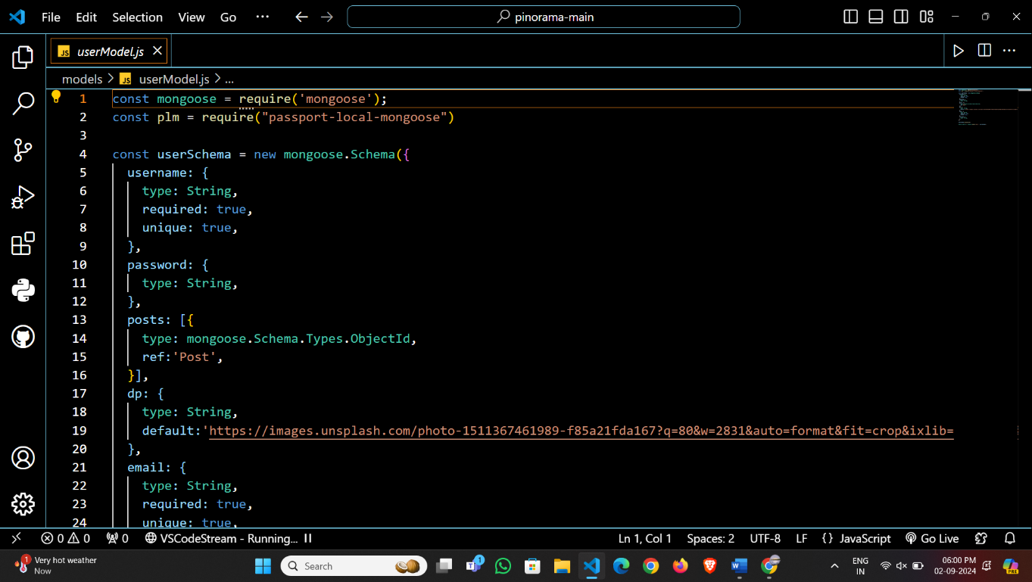

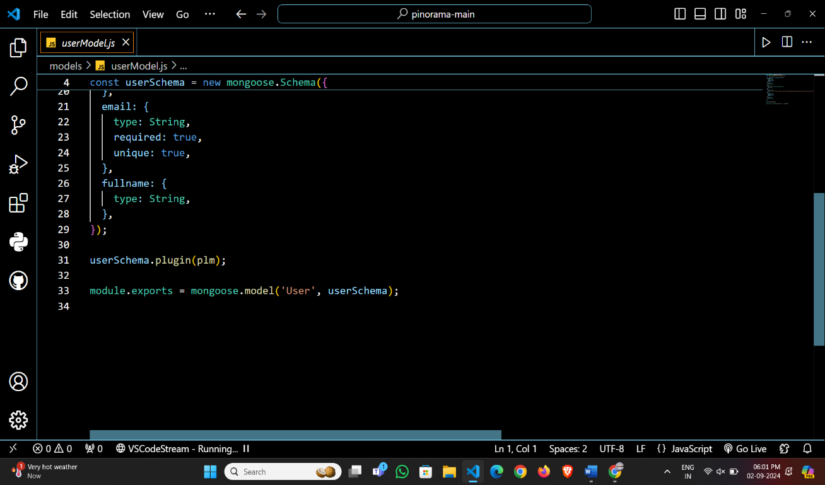

**\*Controllers:**

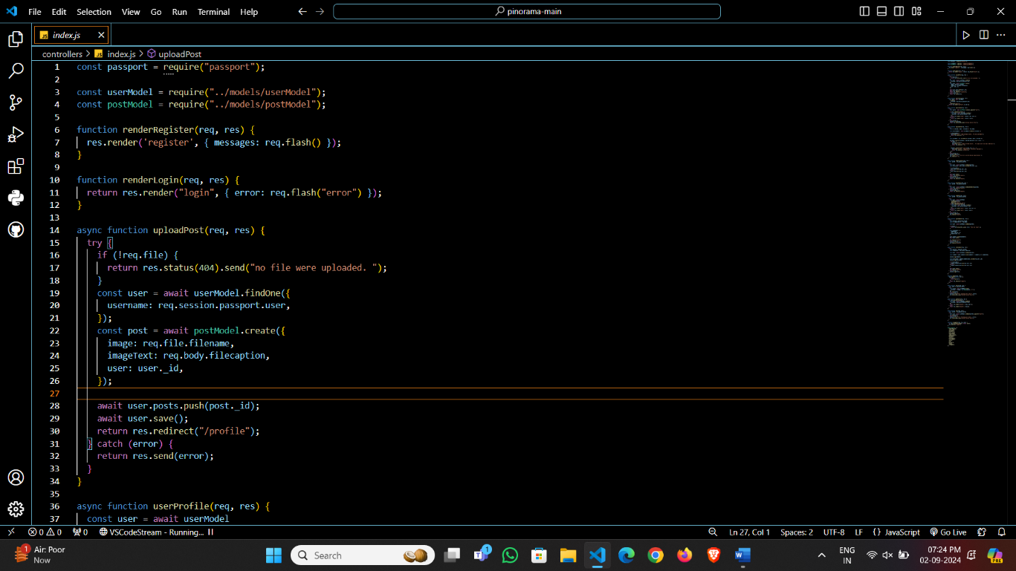

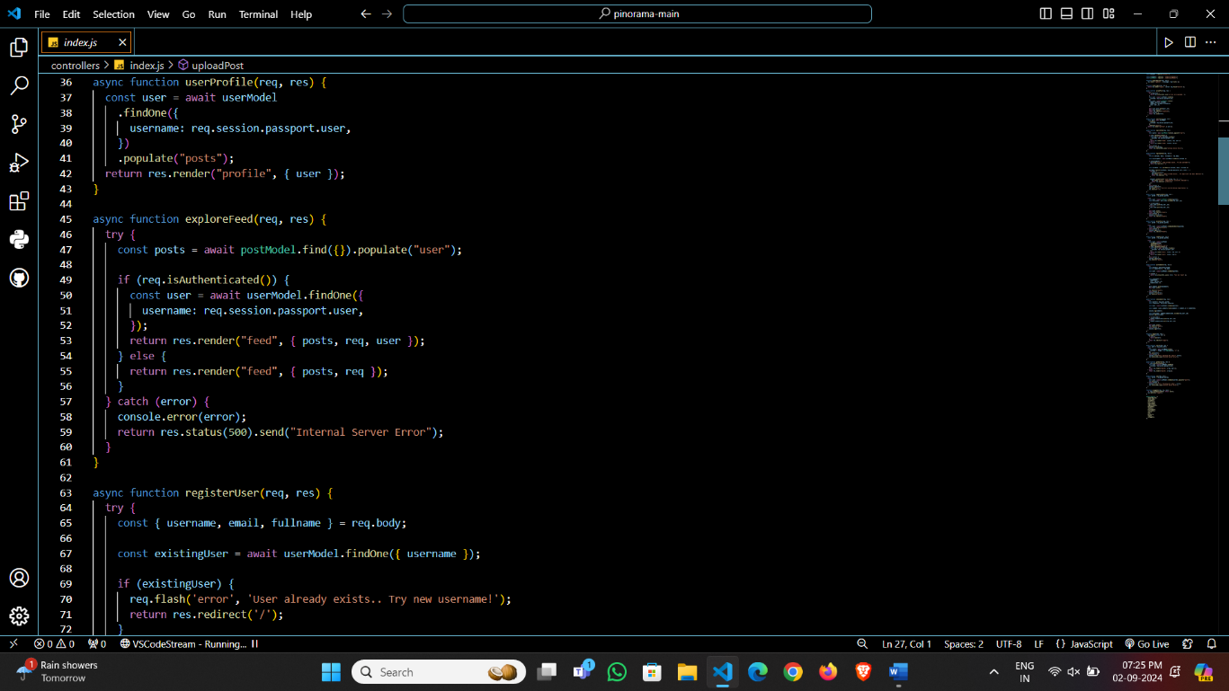

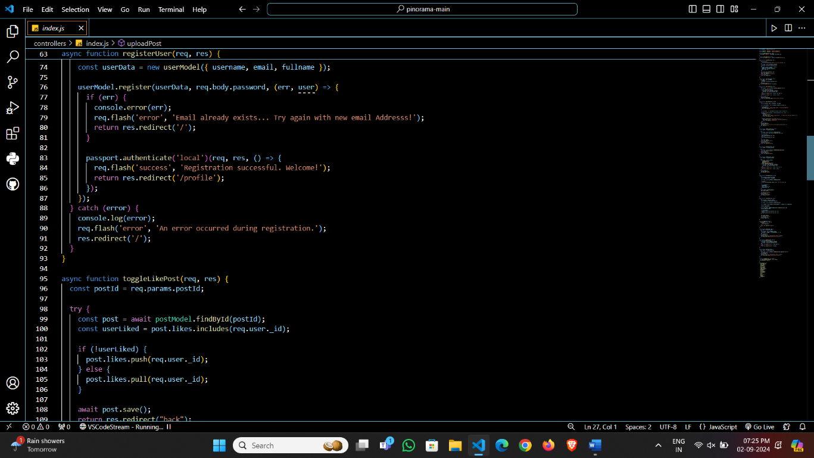

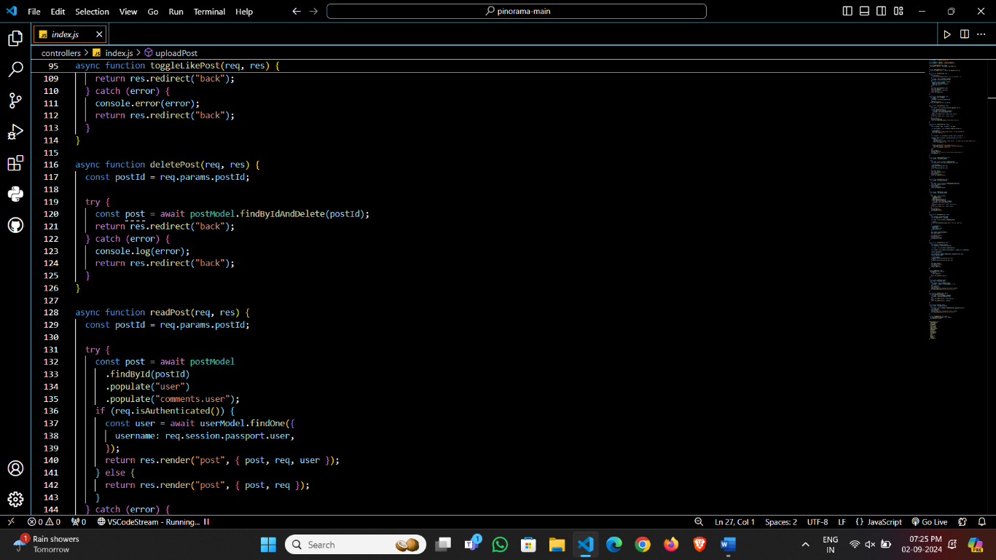

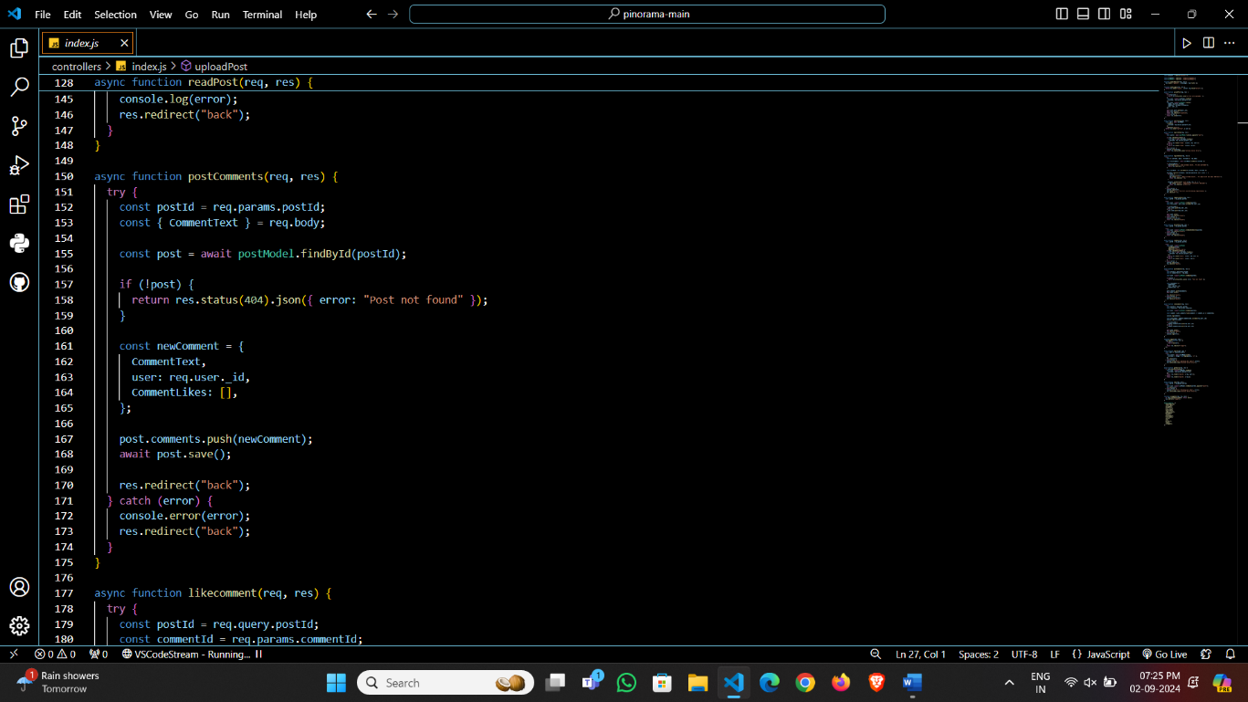

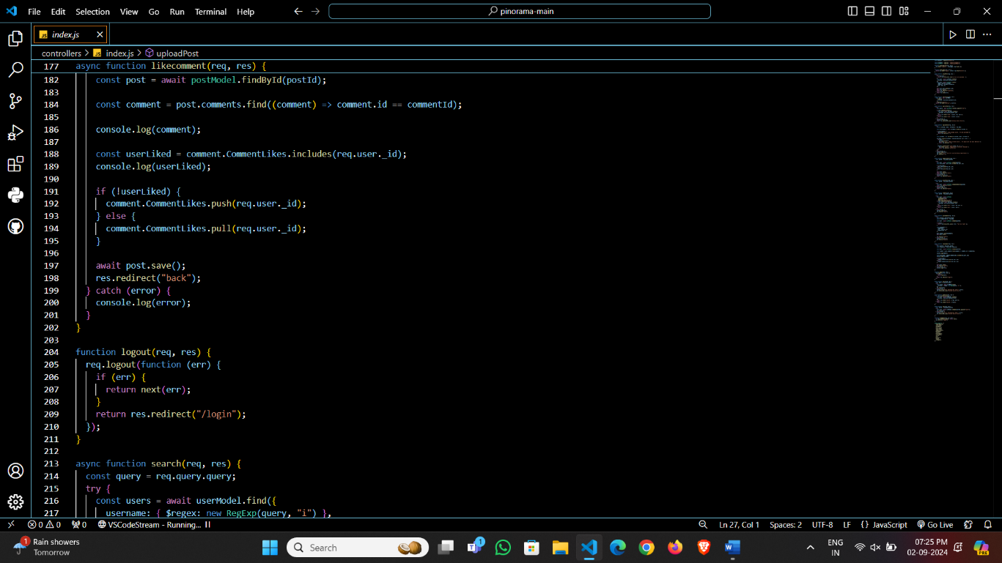

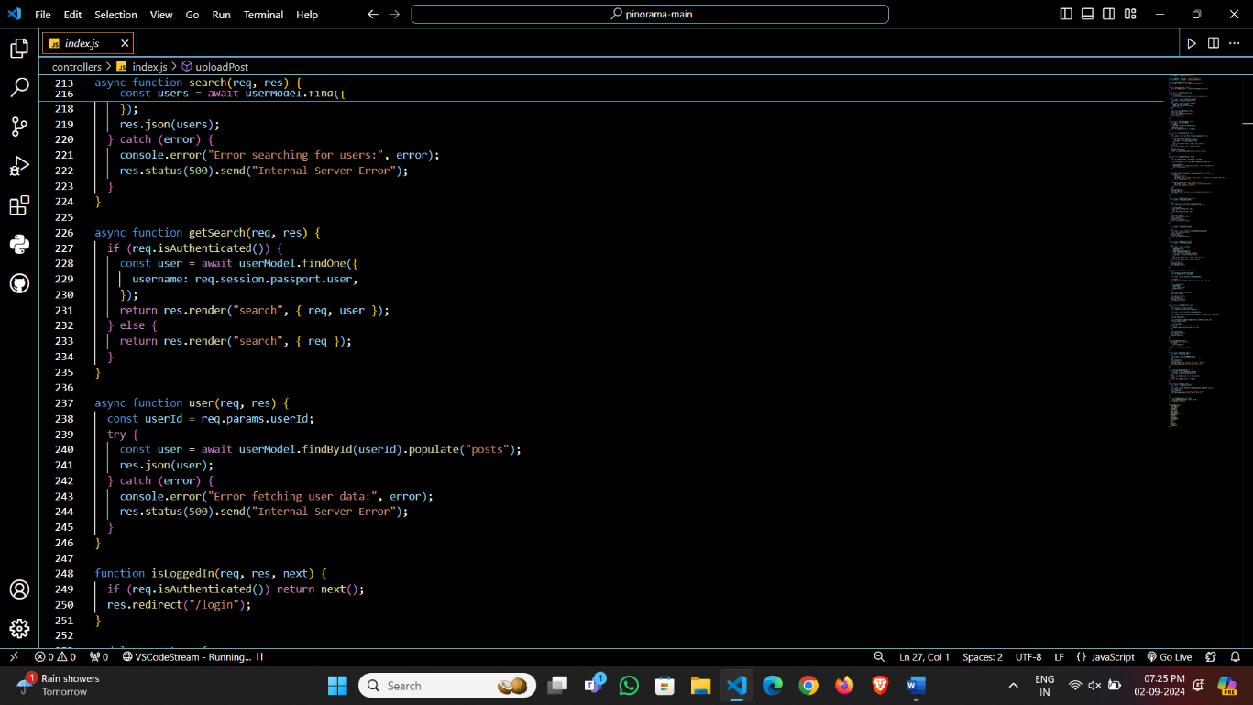

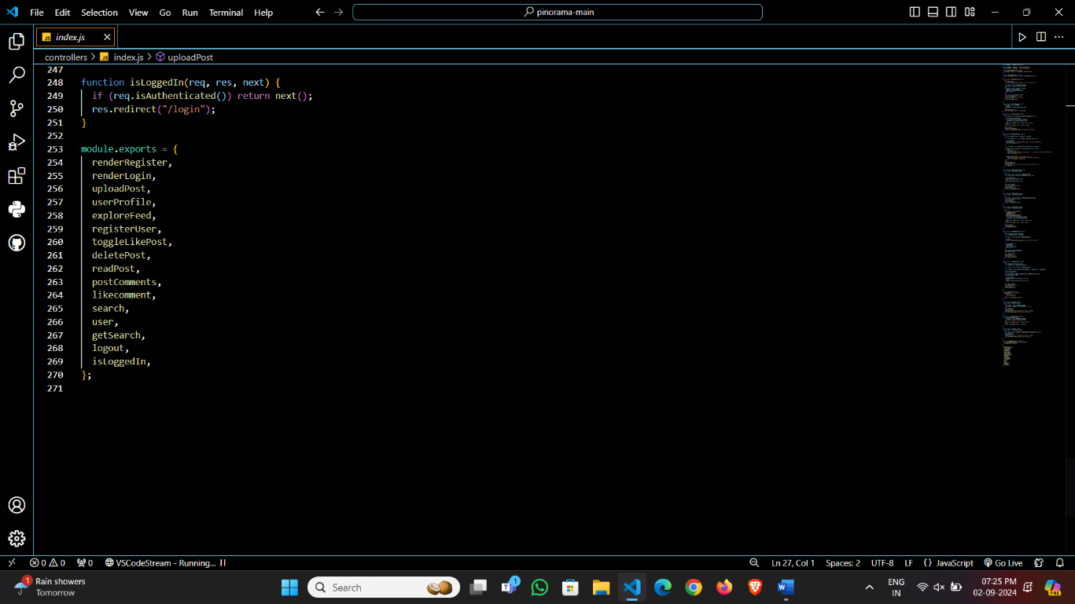

**\*Views:**

* Feed.ejs

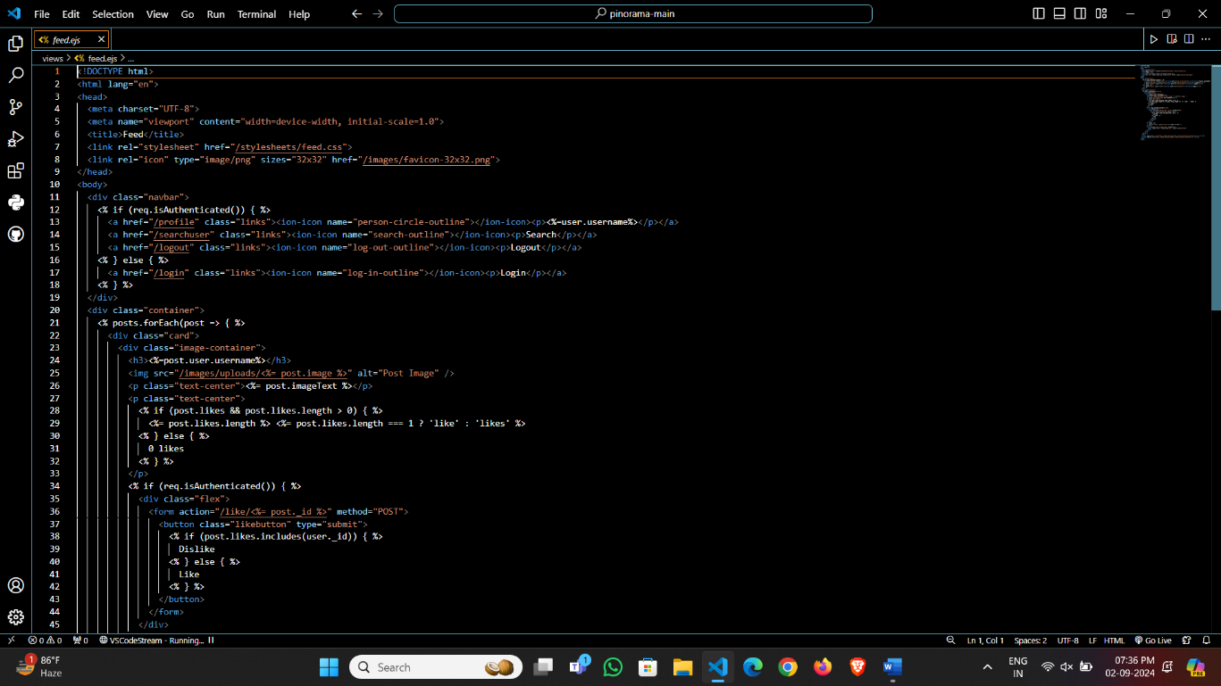

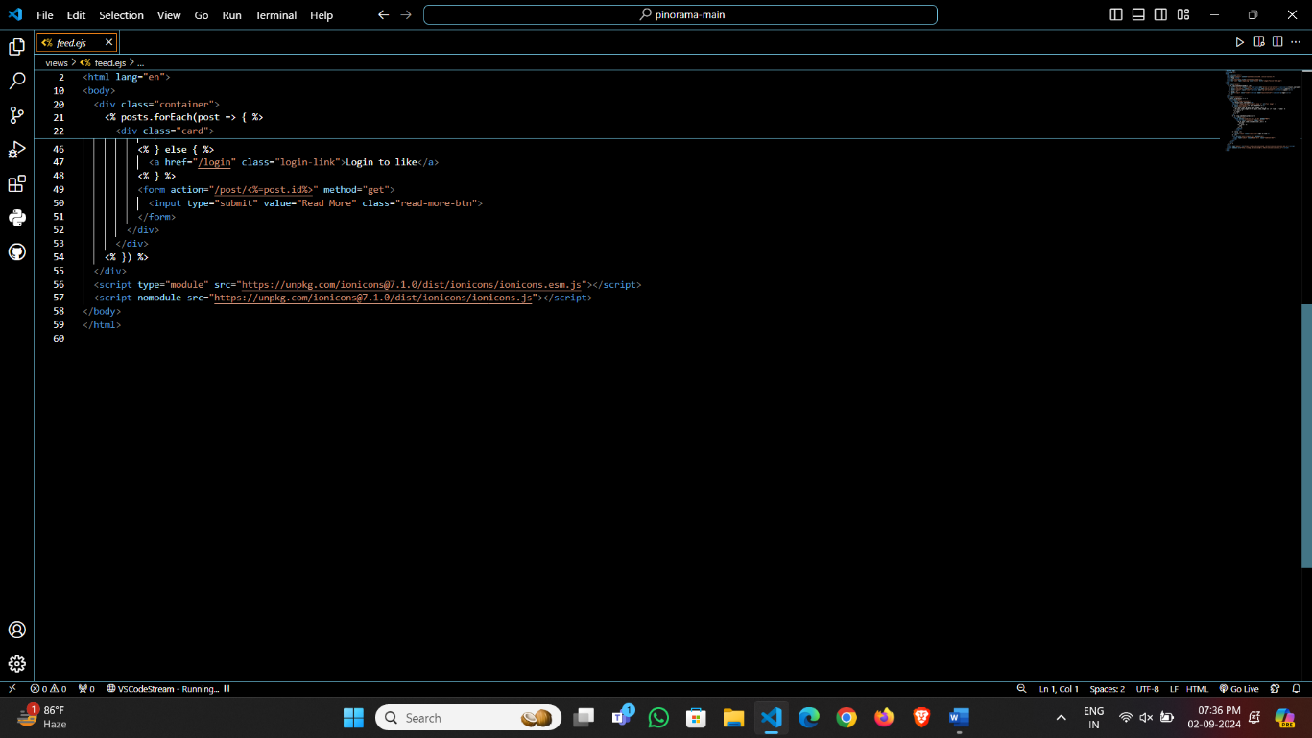

* Login.ejs

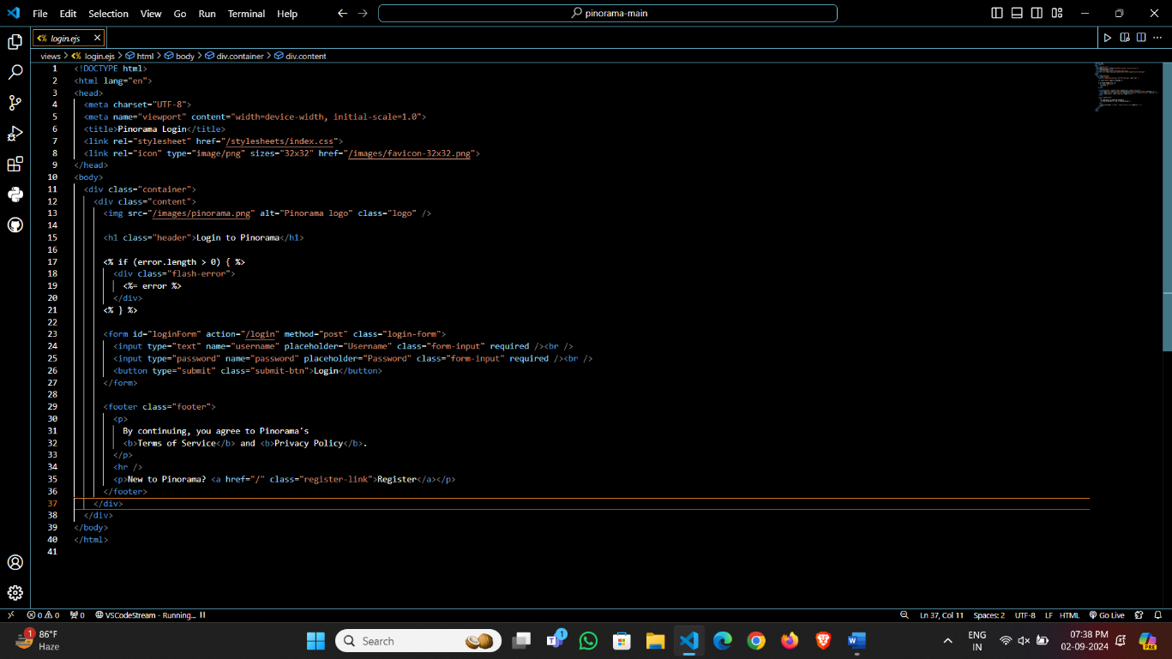

* Post.ejs

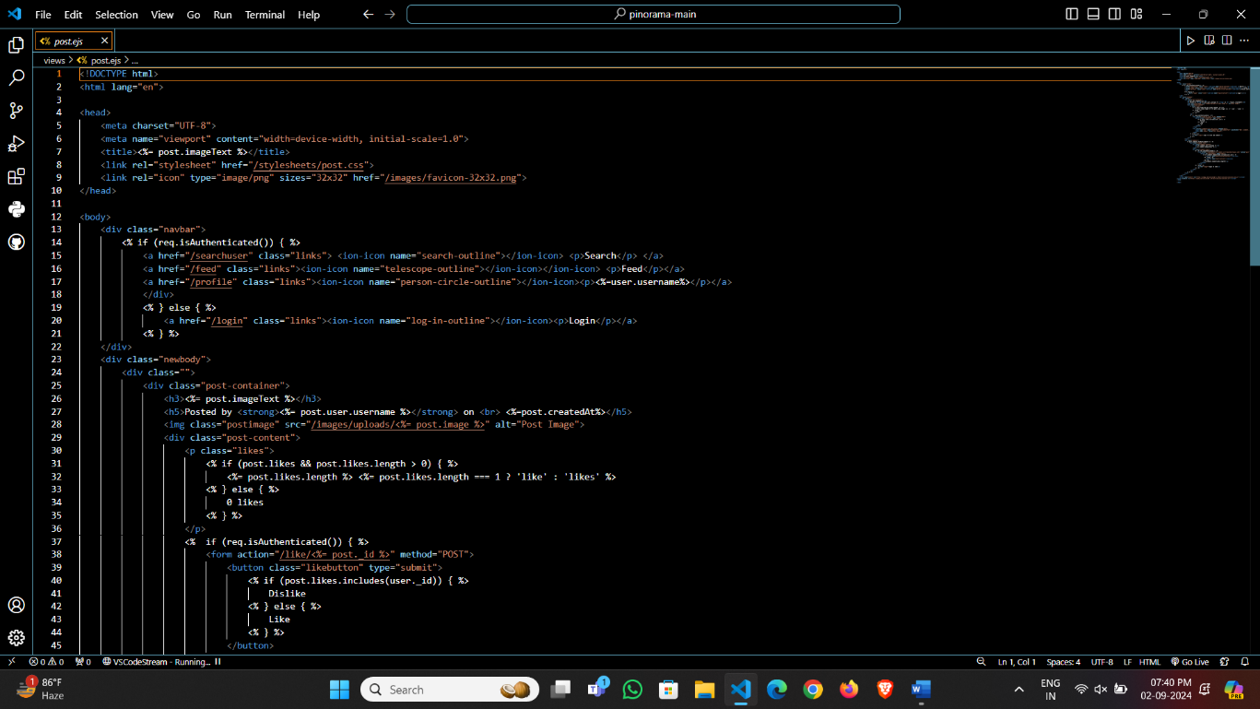

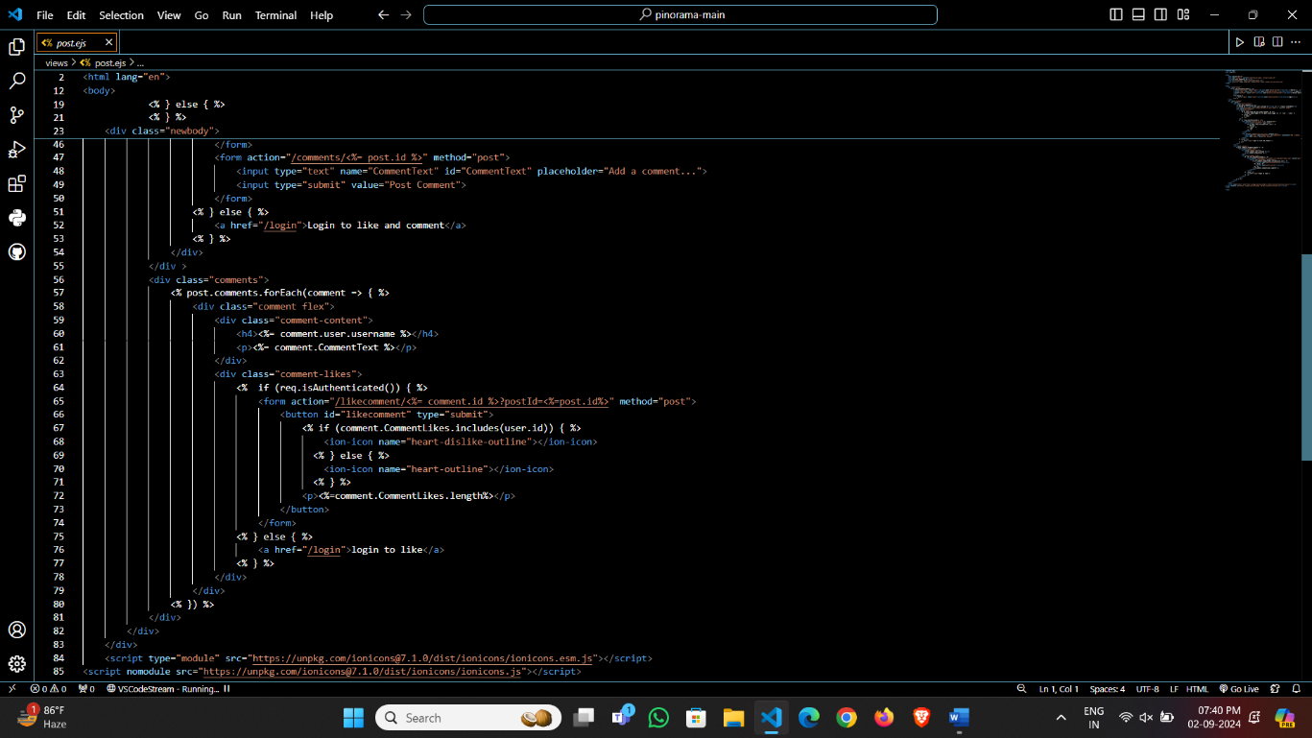

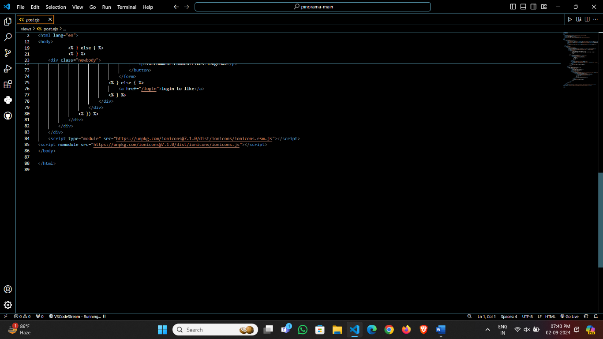

* 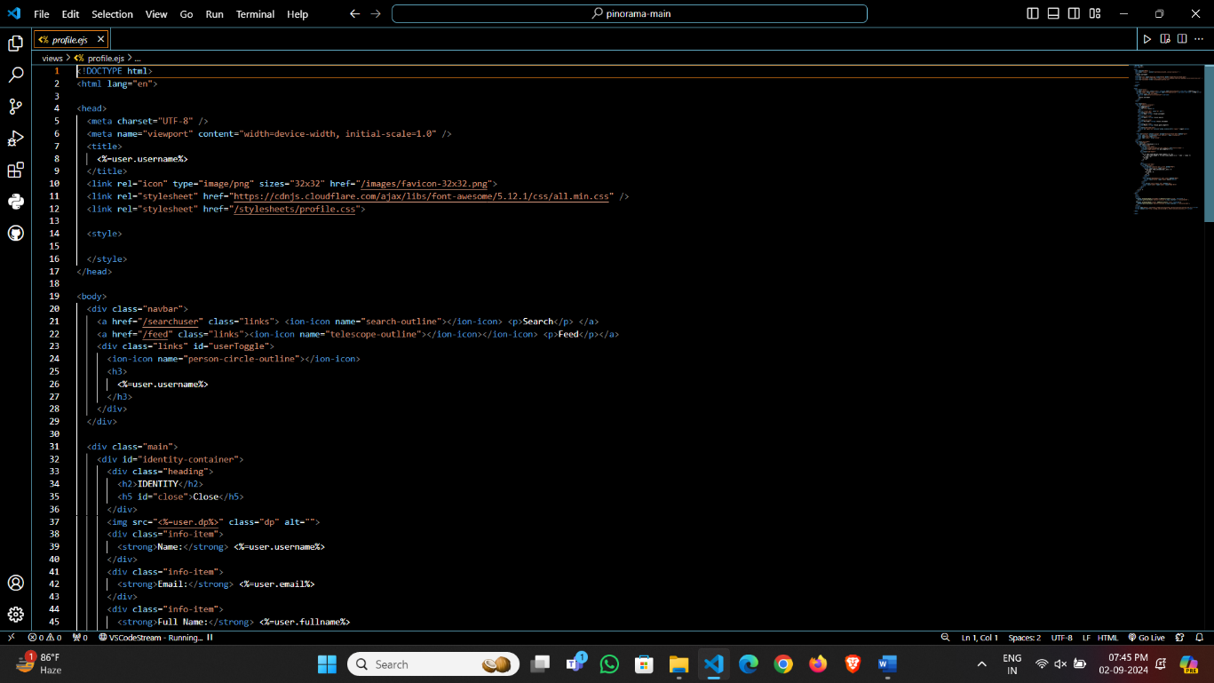Profile.ejs

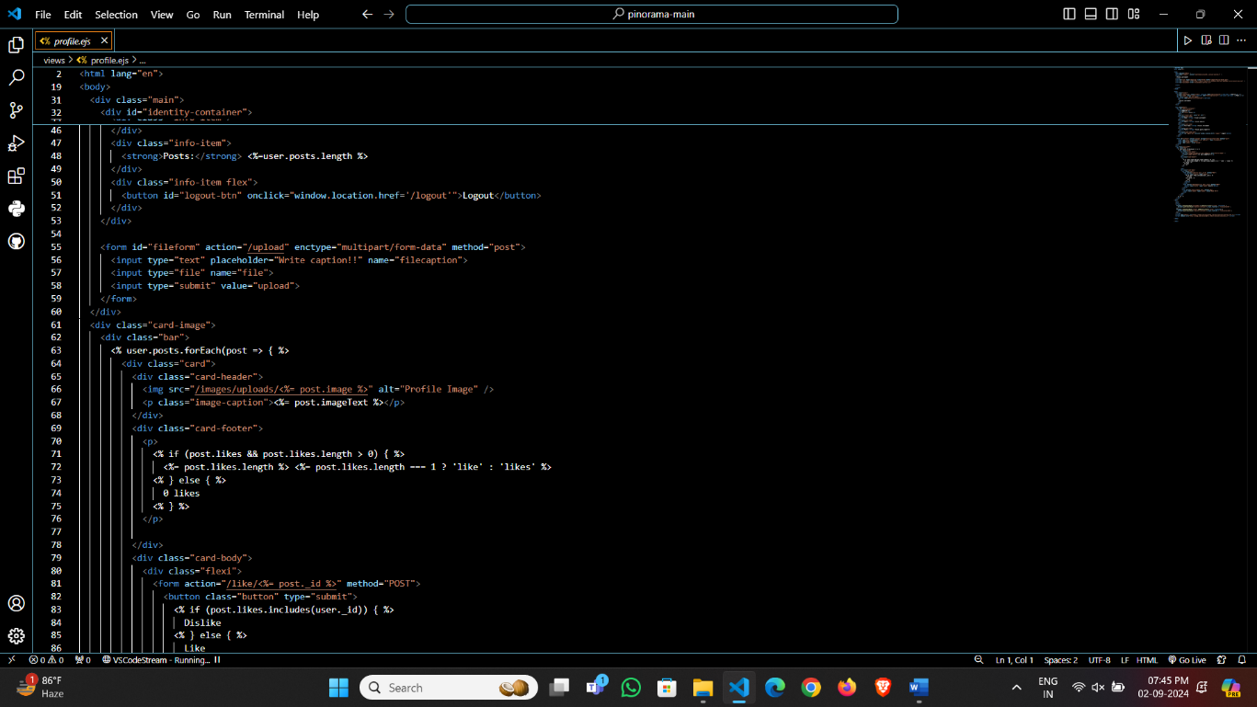

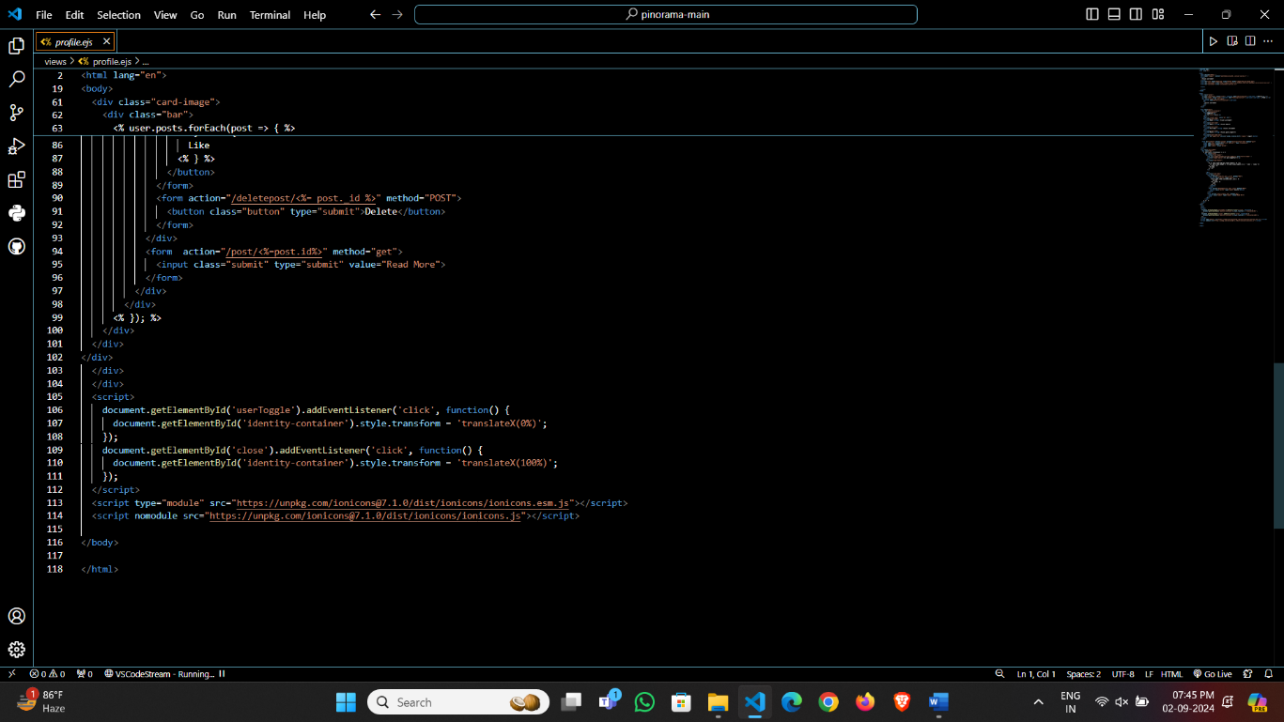

* Register.ejs:

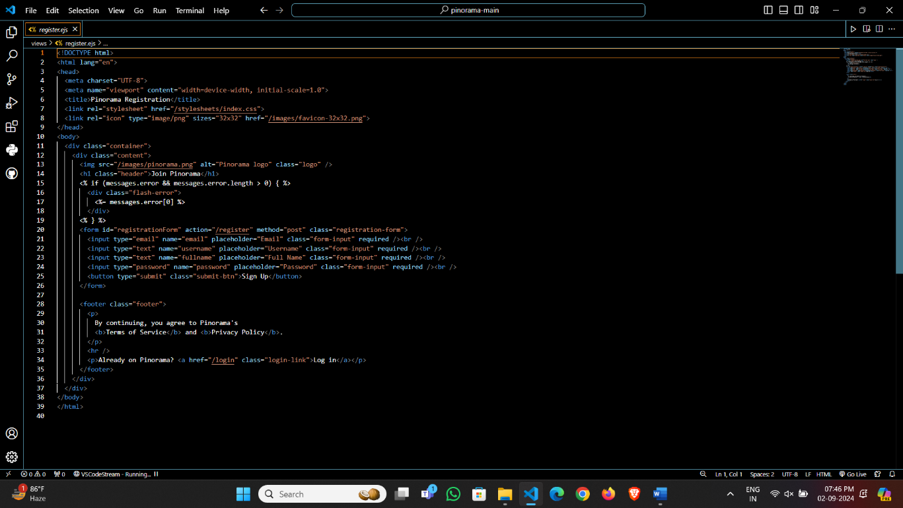

* 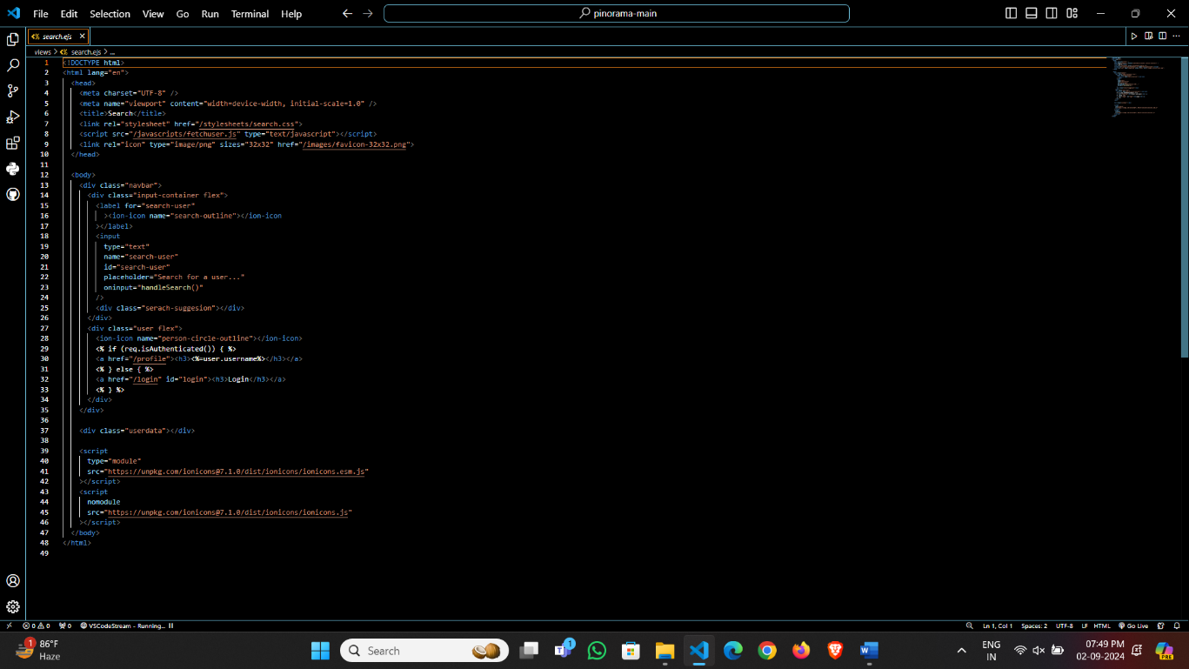Search.ejs:

**\* App.js:**

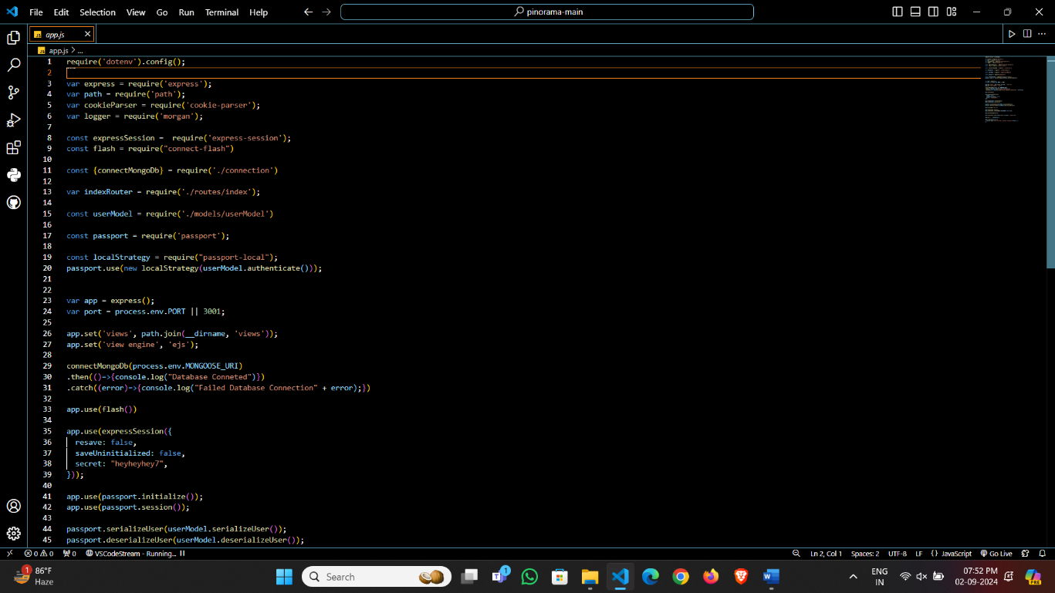

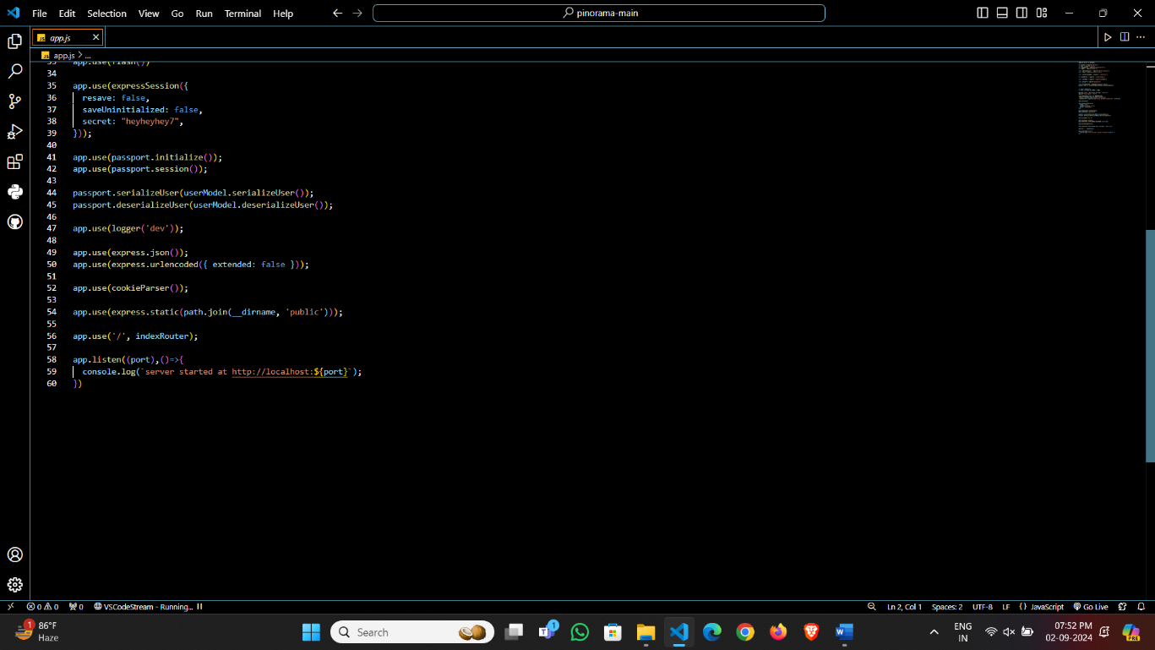

* + 1. Snapshot of Result:

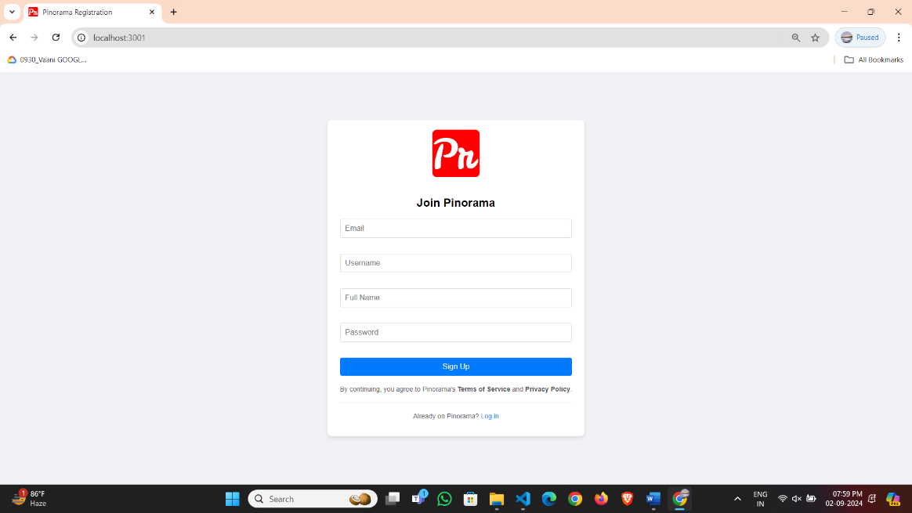

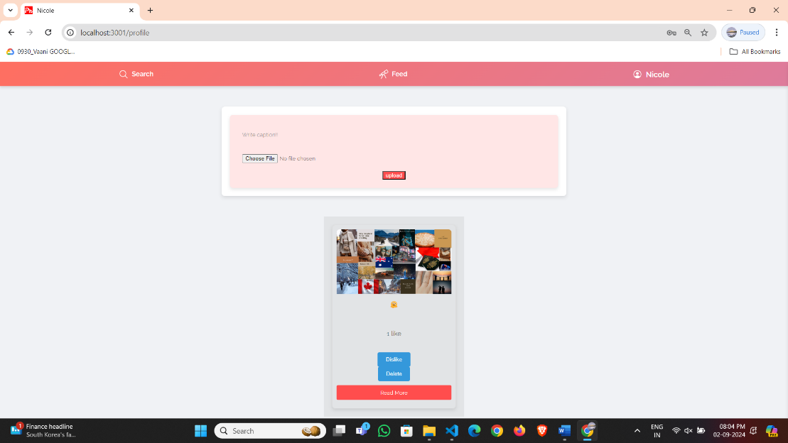

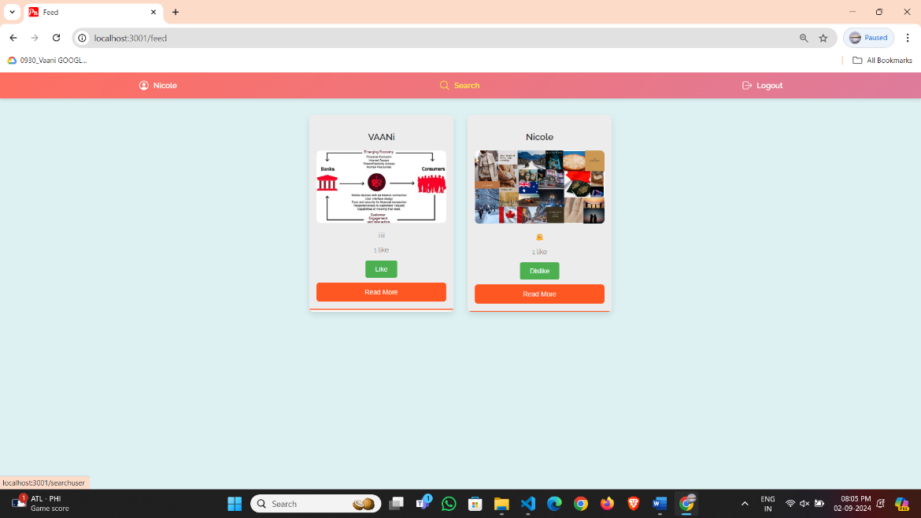

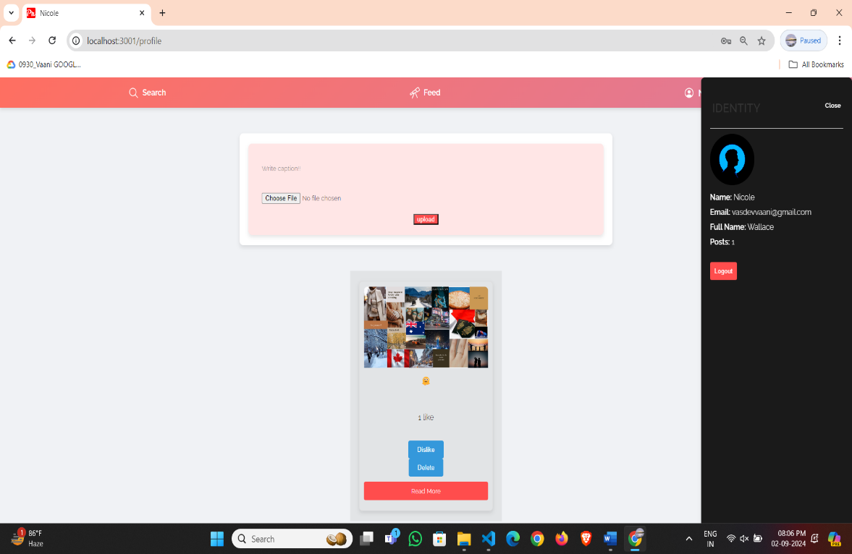

* + 1. MongoDB:

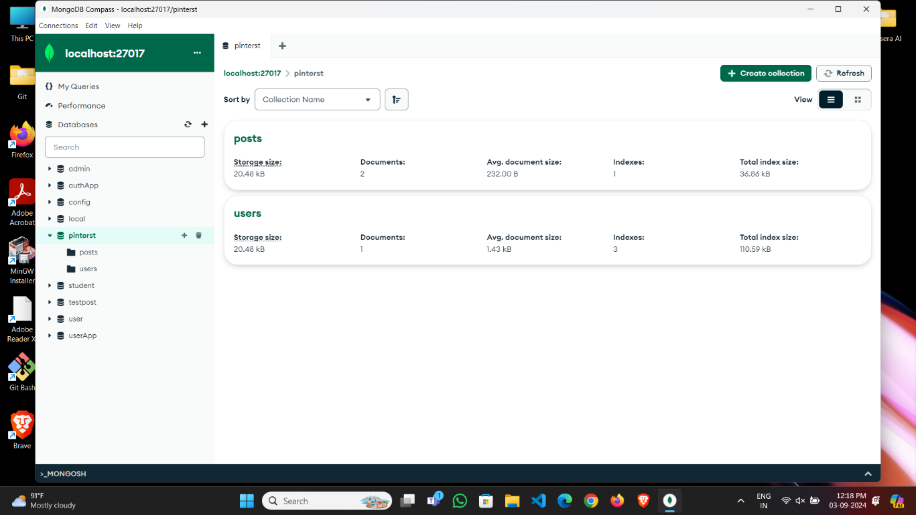

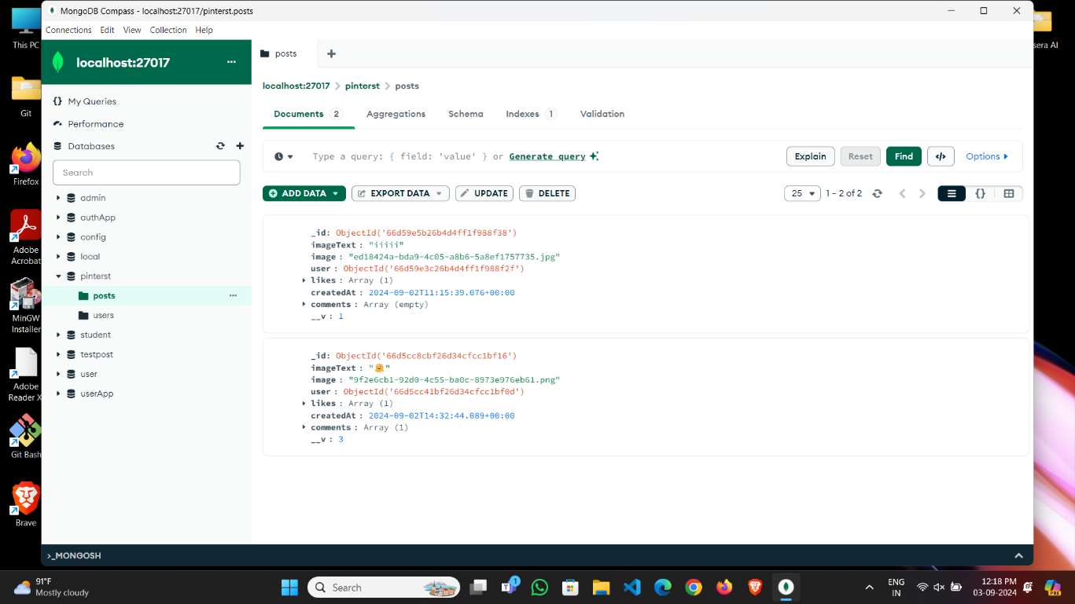

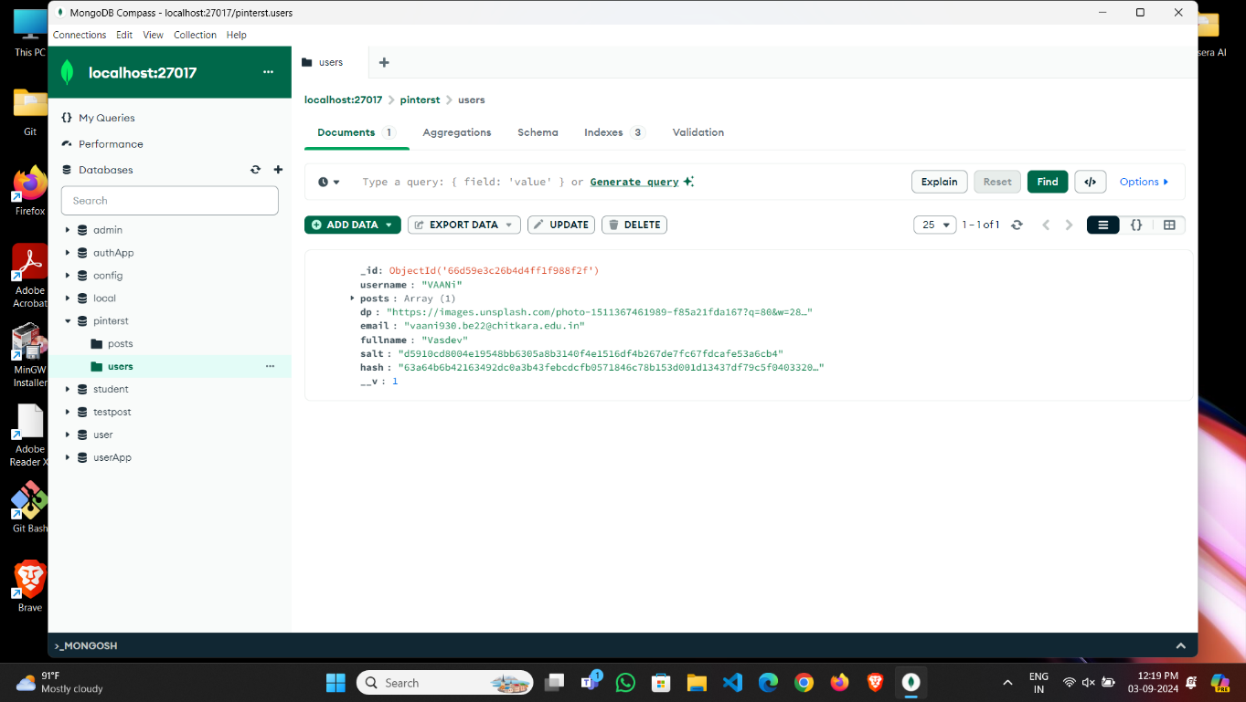

**7.Conclusion:**

When evaluating a social media platform that allows users to add, delete, like, and comment on posts, several conclusions can be drawn:

1. ****User Engagement and Interactivity:**** Such platforms foster high levels of user engagement and interaction. The ability to add posts provides users with a creative outlet and a way to share personal experiences or information. Features like liking and commenting encourage active participation and can lead to richer conversations and community building.
2. ****Content Moderation and Management**:** The ability to delete posts, likes, and comments gives users control over their content and interactions. This can be beneficial for managing personal or professional profiles and maintaining a positive online presence. However, it also requires effective moderation tools to address inappropriate or harmful content and ensure a respectful environment.
3. ****Dynamic and Evolving Content**:** These features contribute to a dynamic content ecosystem where posts can evolve based on user feedback. The ability to like and comment allows for immediate reactions and discussions, while the option to delete provides a mechanism for users to retract or modify their contributions.
4. ****Privacy and Security**:** Allowing users to manage their own posts and interactions can enhance privacy and security, giving users control over what is visible and who can engage with their content. Nonetheless, it is crucial to implement strong security measures to protect against unauthorized access and misuse.
5. ****Community Building and Feedback**:** The interactive nature of such platforms supports community building and user feedback. Likes and comments can provide validation and insight, fostering a sense of connection and community among users. However, this can also lead to issues related to social comparison and pressure to conform.

In conclusion, a social media platform with features to add, delete, like, and comment on posts provides a robust framework for user engagement and content management. While these features enhance interactivity and personal control, they also necessitate careful attention to moderation, privacy, and the overall user experience to ensure a positive and safe online environment.

**8.References:**

* Youtube:- https://youtu.be/T55Kb8rrH1g?si=gCqvQAh--dMUvxiQ